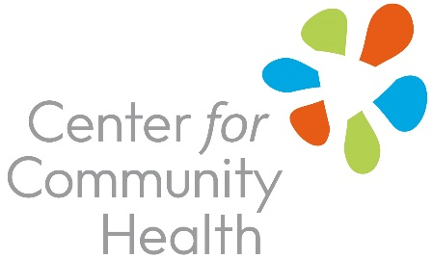
2017 May Mental Health Month

Social Media Messages

Hashtags

Let’s join NAMI and partners across the country in using these hashtags this May:
#StigmaFree #MentalHealthMonth

Twitter
- May is #MentalHealthMonth. Encourage your organization to sign the Mental Health Month Proclamation. See template here: <insert link>
- Take the Make It Ok pledge in May #MentalHealthMonth #ErasetheStigma #MakeItOK http://makeitok.org/take-the-pledge/
- Want more skills to assist family, friends, or coworkers in mental health crises? Try #MentalHealthFirstAid http://www.mentalhealthfirstaid.org/cs
- #MentalHealthFirstAid teaches you how to identify, understand and respond to signs of mental illnesses in your community. www.fairview.org/mentalhealthfirstaid
- 1 in 5 Americans are affected by mental illness. #EraseTheStigma.

http://makeitok.org/see-our-ads/
- #QuestionPersuadeRefer are the 3 simple steps to #PreventSuicide. Find a training here: https://www.qprinstitute.com
- Offering #PsychologicalFirstAid in your workplace will build skills to help others handle mental trauma. Find more here: http://www.health.state.mn.us/oep/responsesystems/pfa.html
- #Mentalillness is not a partisan issue. It can strike anyone at any time. #MentalHealthMonth

Facebook
- This May, <insert org name> is pledging to promote taking the “Make It Ok” pledge and support evidence based trainings as a part of #MentalHealthMonth. You should pledge to #EraseTheStigma #MakeItOK too! <insert link to proclamation template here>
- As many as 1 in 5 Americans are affected by mental illness. Join the Center for Community Health and sign the Make It Ok pledge this May 2017, #MentalHealthMonth
http://makeitok.org/take-the-pledge/
- Watch stories & Learn about individuals living with Mental Illness to understand how to #EraseTheStigma #MakeItOK at http://makeitok.org/see-our-ads/

